IMF Digital Infrastructure Cost Estimator (DICE) Documentation (v1.0.0)

This document provides an overview of the DICE model, describing the parameters and result metrics produced. Explanation is also provided for the selection of the baseline parameters applied in DICE, and the other bespoke parameters which users may want to select for exploration.

The documentation is best read in tandem with viewing the accompanying videos which provide:

* Background on the motivation for DICE ([here](https://www.youtube.com/watch?v=4hnYJKqkelU)).
* Brief technical background for DICE ([here](https://www.youtube.com/watch?v=SEZ4FTHx7Rk)).
* Detailed graphical description of DICE ([here](https://www.youtube.com/watch?v=BgOH8_m_YSA)).

1. The DICE spreadsheet model

The total DICE model consists of over 70 sheets. However, most are hidden from the user’s view for ease of use. The Excel spreadsheet model is separated into two different types of sheets. These include (i) the index, readme and settings tabs which are all denoted in navy blue, and (ii) the results tabs which are all denoted in red.

Figure 1 provides an overview of how the DICE model works, including the demand, capacity, and cost estimation components.

Figure 1 Overview of DICE

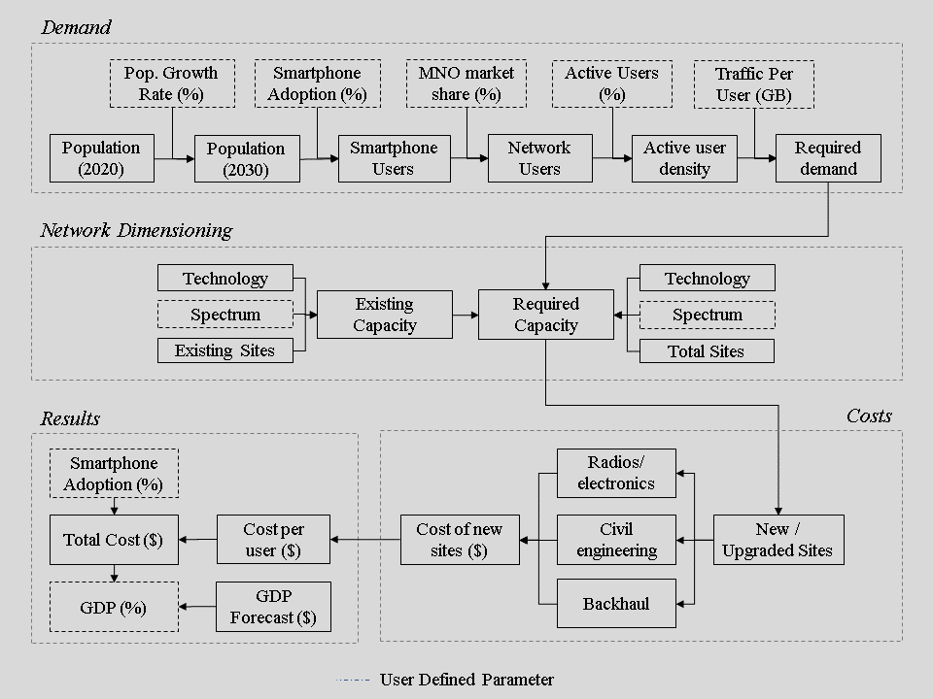

A key premise of the model is the use of ten population density deciles to capture the spatial differences in local areas. All statistical areas for each country are ranked by population density and split into one of these ten deciles. The first decile contains the most populated local statistical areas. Whereas the last (tenth) decile contains the least populated local statistical areas (and thus, the hardest-to-reach).

1. Settings
   1. Index

The general background for DICE is given within the “Index” tab. For example, the aim of DICE is to support high-level decisions pertaining to universal broadband investment. However, there are some caveats to DICE’s capabilities to be aware of, as reiterated here. For example:

* DICE is not a replacement for detailed country-specific modeling. Indeed, the aim for DICE is to provide comparative understanding across all countries globally.
* DICE is not an exact measurement tool. Accuracy and precision are commensurate with being able to make global cross-country comparisons. For further country-specific insights, one would expect a greater level of detail beyond what can be achieved in a country comparison model via DICE. Should this be something desired for a candidate country, please contact the DICE modeling team who can assist.
* DICE is not a stand-alone policy option tool.

The key contribution of DICE is to capture the main cost drivers which affect the deployment of mobile broadband infrastructure and breakdown required investment costs for specific countries, or groups of countries (e.g., income groups or regions).

* 1. Read Me

The DICE approach provides investment analytics for achieving universal broadband, as explained in the “Read_Me” tab. Indeed, DICE complements the IMF’s other SDG infrastructure costing tools, covering roads, electricity, and water and sanitation.

Therefore, comparative country-specific investment needs can be estimated to achieve universal broadband connectivity. The focus is mainly on using 4G mobile cellular connectivity as this technology is one of the cheapest ways to provide wide-area broadband services affordably. Satellite broadband is used only in the hardest-to-reach areas where terrestrial 4G is highly unviable. The level of universal broadband can be specified by the DICE user, based on a desired monthly data consumption quantity.

The estimates DICE produces account for the demographic forecast trends, population density, and economic characteristics of each country.

* 1. Background

As users may be unfamiliar with the current number of unconnected users globally, the "Background” tab provides a set of tables. Each of these tables states the total number of connected and unconnected users globally, as well as by IMF geographic regions and income groups.

* 1. General Settings

The “General_Settings” tab enables the user to view the time horizon of the analysis and select the desired depreciation rate. It is possible to set values for different country income groups. The parameter available can be described as follows:

* Depreciation – The annual discount rate used within the analysis. In the baseline, this parameter is set to 3%.
  1. Countries

DICE allows users to select up to four countries for direct comparison via the “Countries” tab. By clicking on the yellow cells, a drop-down list of all the available countries can be viewed and selected. Once the names of the desired countries have been chosen, DICE will automatically identify the correct International Standards Organization (ISO) three-digit country code (ISO3). For consistency and reliability, the ISO3 code for a country is used throughout DICE to avoid country naming errors (as many datasets use country names spelt in different ways).

* 1. Demand Settings

The costs of mobile broadband are highly sensitive to the traffic demand targets used. Therefore, a significant focus is placed on data demand within DICE, and users need to be aware of key caveats. By clicking on the “Demand_Settings” tab it is possible to inspect a wide variety of demand parameters.

For “Mobile Traffic Demand Parameters”, the key editable metric is as follows:

* Data Demand Per Month (Gigabytes/Month) – Enabling the user to set bespoke monthly data demand targets for different country income groups. This parameter sets the monthly data consumption level per user which DICE will build capacity to serve. As described in the following metrics, the pro rata share of data demand per month is then converted to the daily quantity, and secondly to the busy hour average quantity. Finally, DICE converts this busy hour average quantity into a required connection speed in Megabits Per Second (Mbps).

Intermediate metrics available for the user to view are also described as follows, for DICE to obtain the required final “Hourly Mean Data Rate Per User (Mbps)” metric:

* Monthly Video Streaming (Hours/Month) – The monthly data demand can be converted into the number of hours of Standard Definition (SD) video which can be consumed, given a conversion rate of approximately 500 MB of traffic per hour when streaming on a smartphone.
* Data Demand Per Day (GB/Day) – Reflects the monthly data demand converted pro rata to the daily data demand.
* Data Video Streaming (Hours/Day) – Reflects the number of hours of Standard Definition (SD) video which can be consumed given the daily data demand.
* Hourly Mean Data Consumption Per User (MB/Hour) – The mean number of megabytes consumed per hour by a user.
* Hourly Mean Data Rate Per User (Mbps) – The mean data rate required (in Megabits Per Second) to transfer the required hourly data traffic.

The “Hourly Mean Data Rate Per User (Mbps)” may seem lower (e.g., <1 Mbps) than normally experienced when using a smartphone. However, this is the mean connection speed required over one hour. Usage and traffic demand occur in ‘bursts’, meaning a user normally experiences a much higher rate when downloading data (but these bursts average out over an hour).

In the DICE model, the smartphone adoption rate is set to be 90% of the population by the end of the evaluation period in 2030. Full smartphone adoption of 100% is unlikely for multiple reasons, hence the slightly more conservative aim.

For “User Demand Parameters”, the key editable metric is as follows:

* Active Users (%) – Representing the number of active users exchanging traffic with the network at one point in time. This parameter is required because not all the customers of an MNO are always active. Traffic generally takes place in bursts, where a user receives a call or momentarily uses an app which updates creating a burst of traffic (rather than a continuous stream). Indeed, much of the time, a mobile cell phone may be idle. Therefore, this parameter defines how many users are actively exchanging data at any one time, which is typically one in twenty users, or 5% (as set in the baseline here).

In addition, a set of hourly graphs are provided for users to understand how traffic demand changes over each hour of the day. For example, the quantity of traffic exchanged on average in the early hours of the morning is much lower than in the evening time. This quantity of traffic (the “Hourly Data Consumption Per User”) then correlates with the required mean speed to exchange this data in each hour (the “Hourly Data Rate Per User”).

* 1. Traffic Example

The “Traffic_Example” tab provides a tabular view of the hourly graphs provided in the previous “Demand_Settings” tab in case users want to explore in more detail the underlying estimated demand values.

* 1. Supply Settings

The “Supply_Settings” tab enables users to define certain parameters which affect the delivery of infrastructure. Bespoke control may be required over certain supply metrics used in the analysis, which include the following:

* Existing Spectrum Availability – Allowing the user to set the available amount of 4G spectrum currently in use for the initial capacity estimate in each country income category. Three options are available (Low, Medium and High). The Low option broadly correlates with a single 10 MHz band of spectrum in the downlink (e.g., at 800 MHz), which is a common method for deploying 4G around the world. The baseline option is effectively two 10 MHz bands, and the high option is three 10 MHz bands. Generally, the more bands, the greater the spectrum bandwidth available to exchange data over, increasing the network capacity. Low-income countries usually have smaller spectrum portfolios due to lower data transfer needs, whereas higher income countries often have larger spectrum portfolios due to higher data transfer needs. DICE focuses on modeling the downlink channel, as users generally download more data than they upload, creating a congestion point.
* Future Spectrum Availability – Enabling the user to set the available amount of future spectrum expected. Three options are available (Low, Medium and High) which align with the previous parameter on existing spectrum availability. So, the low case represents one 10 MHz band, the medium case represents two 10 MHz bands, and the high case represents three 10 MHz bands.
* Reliability (%) – Reflecting the ability to alter the guaranteed reliability rate for the demand target set. 5% means that the target data and affiliated speed will be met only 5% of the time and is therefore more similar to a peak speed. Whereas 95% means the chosen data demand target can be almost continually met in the busiest hour of the day, with 95% reliability.
* Satellite Coverage Density (Population Per Km2) – Not all users will be able to connect via terrestrial mobile infrastructure due to viability problems in hard-to-reach areas. Therefore, it is possible to set the population density threshold for areas which will need to rely on satellite broadband services instead of terrestrial 4G. For example, the baseline 1.6 persons per km2 means that areas with a population density below this value will rely on satellite broadband.
  1. Cost Settings

The “Cost_Settings” tab enables users to have bespoke control over the cost model parameters used within DICE. Three separate areas of control are provided.

Firstly, the “Operational Expenditure” box contains:

* Opex as a Proportion of Capex (%) – Enabling the user to specify how much the annual operational expenditure is, as a percentage of the overall infrastructure investment. Typically, in telecoms, the annual operational expenditure for asset operation and maintenance is broadly equivalent to 15% of the initial capital expenditure cost, thus this is set as the baseline value. However, it is also possible to edit this parameter to either 5%, 15% or 20% of the capital expenditure cost.
* VSAT Opex (US$/Month) – Sets the cost per month of a satellite broadband service.

Secondly, the “Equipment Costs” box contains the following parameters:

* RAN ($) – Reflecting the USD capital cost per site for the Radio Access Network (RAN) electronics which are positioned at the top of a cell tower (all active electronic radio cell equipment).
* Fiber ($) – Reflecting the USD capital cost for a fiber optic link per kilometer.
* Wireless Backhaul ($) – Reflecting the USD capital cost per site for a single wireless backhaul link.
* Tower ($) – Reflecting the USD capital cost for the civil engineering investment required to build a 30-meter cell site structure.
* Power System ($) – Reflecting the USD capital cost per site for the power system fitted at the bottom of a cell tower, either to connect to a fixed local grid, or consisting of a battery and solar generation equipment.
* VSAT Terminal – Reflecting the USD capital cost for a satellite broadband terminal.
* Policy and Regulation – Reflecting the USD cost per user to contribute to policy and regulatory activities.
* ICT Skills / Content – Reflecting the USD cost per user to contribute to ICT skill training and content.

Finally, the “Labor Effort” box consists of the following parameters related to building or upgrading any assets:

* Planning & Surveying – Reflecting the number of days and employees allocated to planning and surveying a site location for a greenfield site construction.
* Logistics – Reflecting the number of days and employees involved in moving equipment and resources to a site location for a greenfield site construction.
* Construction – Reflecting the number of days and employees involved in building a civil engineering cell site structure at a new cell site location for a greenfield site construction.
* Installation - Reflecting the number of days and employees involved in installing new RAN equipment at either a new greenfield site construction or upgrading an existing site.

Once these parameters have been set, the number of “Hours of Work” is estimated, consisting of the number of days of effort (with 8 hours per day) multiplied by the number of employees. This hourly total is then converted to a cost based on the estimated labor cost for each country.

1. Results
   1. Country Context

The “Country_Context” tab provides an overview of various key metrics which affect the costs of deploying universal mobile broadband by country.

Four key graphics are presented which include:

* Population by Density Decile – Representing the total population of each of the ten population density deciles. The largest population is in the first decile, whereas the smallest population is in the last decile.
* Area by Density Decile (km2) – Representing the geographic area in square kilometers of each of the ten population density deciles. The smallest area is in the first decile, and the largest area is in the last decile (so the inverse pattern to the population by decile). Some countries may slightly diverge from this pattern if the local statistical areas available are coarse.
* Population Density by Density Decile (Pop/km2) – Representing the population density of each of the ten population density deciles. The first decile has the highest population density.
* Population Growth Forecast (%) – Representing the UN estimated population growth forecast over the next decade for each country.
  1. Country Demand

The “Country Demand” tab enables users to explore the data demand for three related metrics based on the given population deciles:

* Total Smartphone Users by Density Decile – The total estimated smartphone users by density decile.
* MNO Active User Density by Density Decile – The estimated number of active users in each density decile for the hypothetical modeled Mobile Network Operator.
* MNO Traffic Density by Density Decile– The estimated traffic density for each population density for the hypothetical modeled Mobile Network Operator. 
  1. Cost Per User Per Country

The “Cost_Per_User_Per_Country” tab reports the cost per user estimate for each selected country broken down by six cost segments, including:

* Mobile infrastructure capex – Reflecting the capital expenditure necessary to be spent on mobile infrastructure (e.g., RAN, towers, backhaul etc.).
* Metro and backbone fiber – Reflecting the capital expenditure necessary to be spent on fiber optic network assets for transporting large quantities of data, within urban areas and over long distances.
* Mobile infrastructure opex – Reflecting the operational expenditure necessary to be spent on mobile infrastructure (e.g., power, operation and maintenance etc.).
* Remote coverage – Reflecting the cost of providing satellite broadband in remote areas.
* Policy and regulation – Reflecting the necessary investment per user to ensure effective policy and regulation.
* ICT skills/content - Reflecting the necessary investment per user to ensure users have sufficient skills to utilize connectivity services, and that there is useful content available in local languages.
  1. Cost Per Country

The “Cost_Per_User_Per_Country” tab reports the total cost estimate for each selected country, broken down by the six major cost segments highlighted in the cost per user per country section.

* 1. Cost by IMF Income Group

The “Cost_by_IMF_Income_Group” tab reports the total cost estimate for IMF income groups, broken down by the six major cost segments highlighted in the cost per user per country section.

* 1. Cost by IMF Regions

The “Cost_by_IMF_Regions” tab reports the total cost estimate for all IMF regions, broken down by the six major cost segments highlighted in the cost per user per country section.

* 1. Validation

The “Validation” tab reports the total estimated investment by cost segment, International Telecommunication Union regions, and World Bank income groups, to provide a comparison to the ITU Connecting Humanity study.